**Website:** [**https://zeencollagen.com/**](https://zeencollagen.com/)

**Dated: 07/02/2020**

**PRROPOSAL FOR SEO/SMO/PPC**

**SEO:**

**We have conducted an SEO audit for your website and below are the observations from the same. These are the points where we are weakening in terms of SEO.**

**We have analyzed your Website:** <https://zeencollagen.com/>

* **Site Audit**
* **Content Audit**
* **Competitor Analysis**

**Below are the points which we have observed we need to fix.**

* **PAGE ANALYSIS:**

1. **Meta Description: we need to add Meta description in your website,** [**Meta descriptions**](http://en.wikipedia.org/wiki/Meta_element#The_description_attribute)**are useful because they often dictate how your pages are shown in search results. For optimum effectiveness will keep it 160-300 characters.**
2. **Content Ratio: We would suggest more content on your website as Google loves good quality content page, as content is king.**
3. **Heading Tags: We suggest implementing Heading Tags. To get more impactful we can add keywords in heading Tags.**
4. **Micro formats: This page does not utilize Micro format markup.** [**Micro format**](http://en.wikipedia.org/wiki/Microformat)**is a markup that is used to structure the data that is being sent to search engines more effectively. Will validate your markup with the**[**Google Structured Data Testing Tool**](https://search.google.com/structured-data/testing-tool/#url=https%3A%2F%2Fzeencollagen.com%2Fen%2Fzeen-products%2F)**.**
5. **Image Alt TAGS: we have found some pages missing ALT attributes.as we all know Google does not read any image so we put any alternative text to recognize the images.**

* **Mobile Compliance:**

1. **AMP: we observed your website’s page does not have an AMP version. We should creating Accelerated Mobile Pages, which is an easy way to make your pages load instantly on any mobile device.**

**Though AMP is not a ranking factor. AMP does affect clicks, impressions and user experience, which in turn affects SEO.**

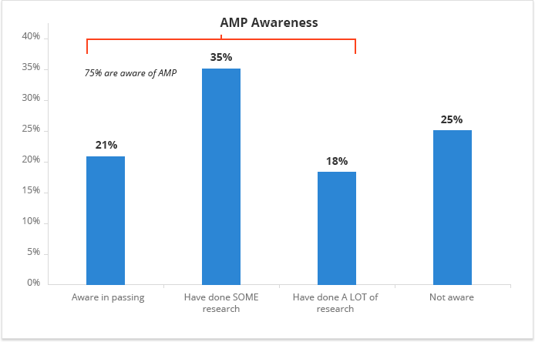

1. **Google Search Console: This tool plays vital role between client and Google.by this tool we can analysis the crawl, index and serving information of you page .any unwanted link we can disavow by this.**

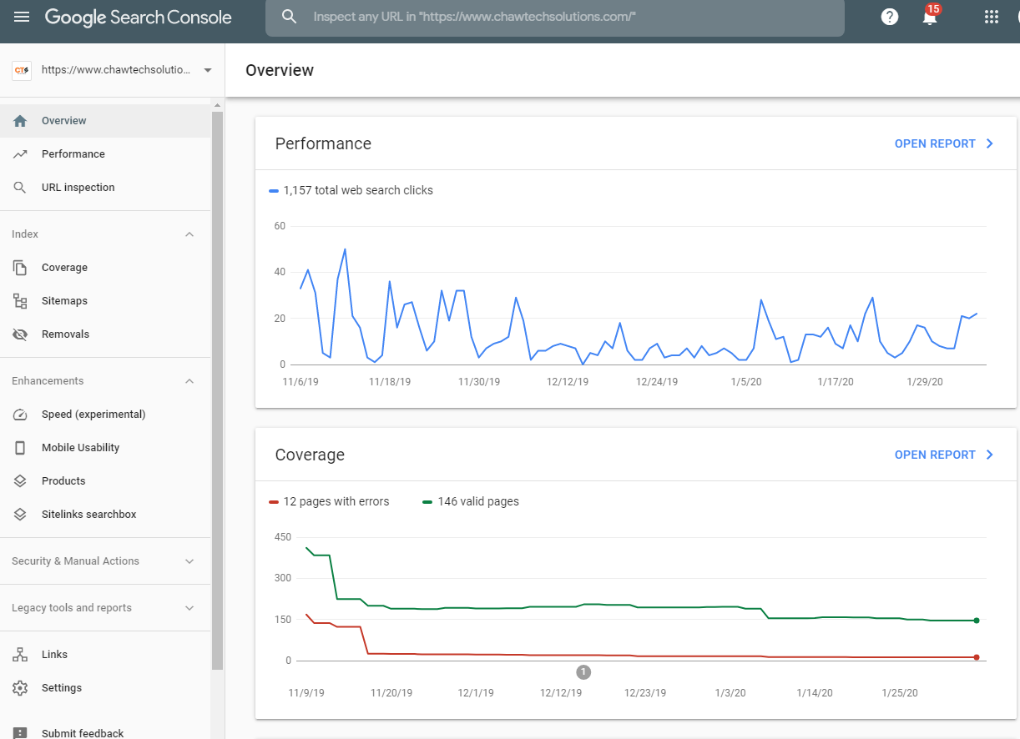

* **Backlink Analysis: There are only 31 Backlinks in the website. Which can be weaken website SEO later on .because Google give more credit to that have more good quality backlinks.so we will create the good quality backlink through many activities ,which we have covered in below section:**

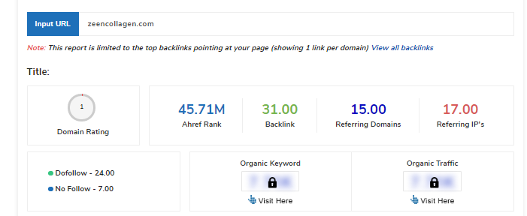

**We would be targeting that website that has good page authority and domain authority.**

**To get more and good quality backlinks we will be doing below activities on daily basis:**

1. **Bookmarking**
2. **Blog Submission**
3. **Classified submission**
4. **Article submission**
5. **Image and PPT submission**
6. **Web2.0**
7. **Press Release submission**
8. **Info graphic creation and submission**
9. **Forum Submission**
10. **Directory submission**
11. **Referring Domains: Only 15 referring domain found, need to create more by doing some off page activities on daily basis mentioned above.**
12. **Referring IP’s:17**
13. **Do follow Links: 24**
14. **No follow link: 7**

**Our Strategy would be when building backlinks not focus only on the quantity of links instead go for quality and relevance link too.**

* **Keyword Analysis:**

#### **Keywords Consistency: we have found page’s main keywords are not distributed well across the important HTML tags.**

**Our strategy would be like page content must be focused around those keywords we would like to rank for and also distributed across such as title, Meta tags and Header tags.**

1. **Performance Results: Your page performance needs improvement**

**Website Performance can indirectly affect search engine ranking. Below are the factors where we need to focus**

* **Page Speed information:**

**Your page's server response time is slow. Need to optimize this to improve user experience.**

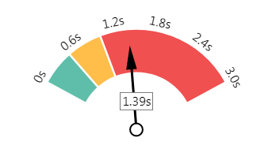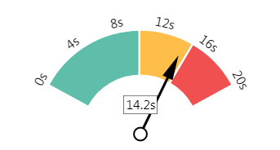

* **Page size information**

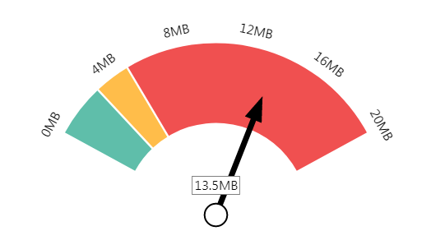 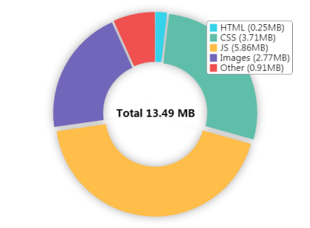

* **Deprecated HTML**

**Inline CSS: Inline styles are an older coding practice and discouraged in favor of using CSS style sheets, due to their ability to degrade page load performance and unnecessarily complicate HTML Code.**

* **Competitor Analysis:**

1. **Competitors Backlink audit: This is very important and crucial part of SEO. We should always analyze the link profile of competitors and look for opportunities that can improve link building and search performance.**

**We will be checking all the competitors’ backlink (inbound link) that are pointing to top ranking pages, so we won’t miss out any important link opportunities.**

1. **Competitor’s keywords: we need to put some more keywords by which competitors rank for.so In future we will be on top by many keywords and our competitors will not beat us.**

**SMO: For brand promotion: Can get maximum Benefits by doing following activities on daily basis.**

**Daily Activities:**

|  |  |  |
| --- | --- | --- |
| 1. **Facebook**      1. **LinkedIn**      1. **Twitter** 2. **Instagram** 3. **Pinterest** | * **Post on daily Basis** * **Video Promotion on Facebook** * **Blogs** * **Post Banner related to Business** * **Daily Post** * **Articles** * **Banners** * **Company Page creation** * **Daily Tweets** * **Daily post activity where you can increase followers** * **Daily post activities with hash tags** * **Daily post activities on pinterest** |  |

**PPC POPOSAL:**

**We need to use all the PPC food groups in a right way, with the right portion then we’ll be able to get the highest ROI possible:**

**Show your ads more often to people searching for what your business offers**

**We offer maximum clicks, impression and CTR with minimum budget**

**PPC Strategy: steppes to be followed for the Good PPC campaign.**

1. **Audience Targeting :**

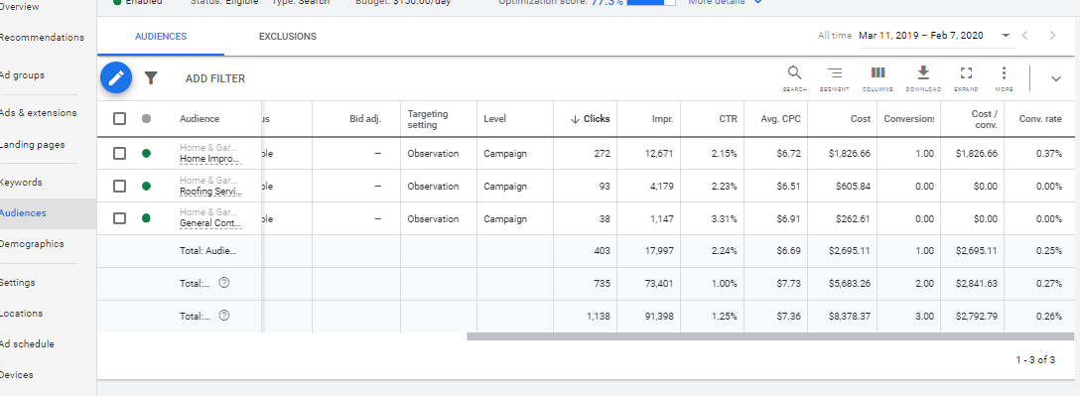

1. **Landing page:**

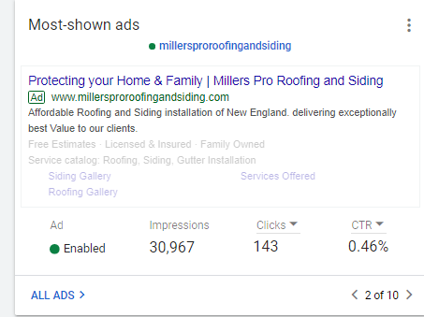

1. **Writing effective ad copy: most important factor for Google ad words:**

* **Call extension ads**
* **Text ads**
* **Site link extensions**

1. **Bidding Strategy**
2. **Keywords research and suggestions**
3. **Will target to new keywords to reel in your highest value conversion**
4. **Set up the audience is an again important factor.**
5. **Ad schedule: Your ads are eligible to show all the time**

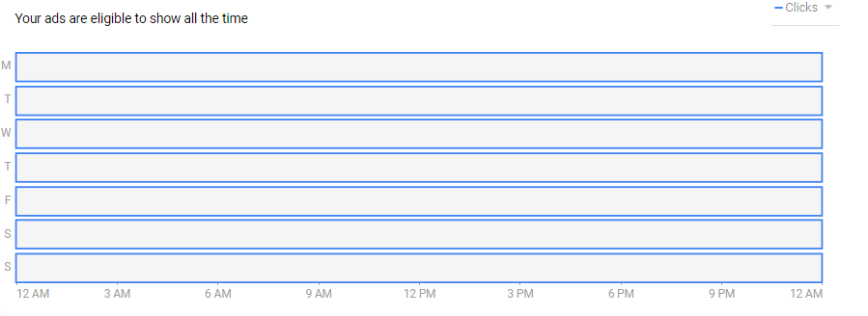

1. **Locations: we can focus those cities where we want to target our campaign and can exclude those where we don’t want.**

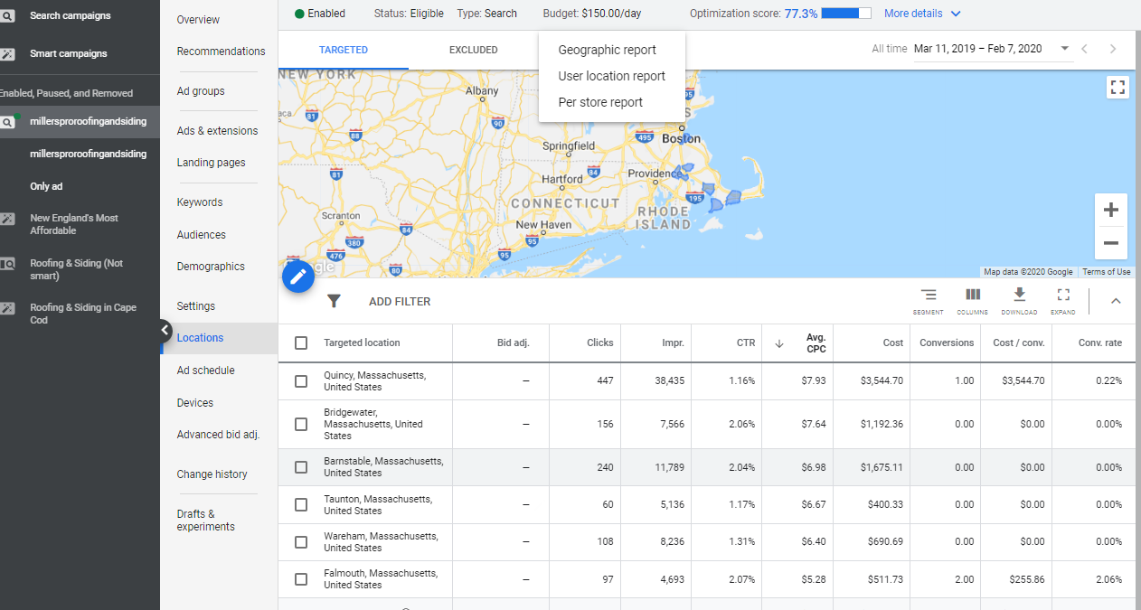

**------------------------------------------------- End of Document----------------------------------------------------**